
Design and Construction of Ackerman Steered Robot

Deliverable 1
EML4552

Group 14
January 15, 2008

QUINN, KYLE
SOSA, JULIO
STEEL, ROBERT



Restated Project Scope

Problem Statement
Currently no off the shelf robotic vehicles come equipped with Ackermann steering capability; they have skid steering, or some other form of steering that have limited maneuverability. Furthermore, none of the available packages have an independent suspension system for off-road use. The project we are tasked with for our Senior Design project, is to design and assembly a small robotic vehicle that incorporates both Ackermann steering and an independent suspension.

Justification/Background
The client that we will be working for is CISCOR (Center for Intelligent Systems, Control, and Robotics) at the FAMU-FSU College of Engineering. Our primary contact and faculty advisor at CISCOR is Dr. Emmanuel Collins. All of the robots currently used by CISCOR are made using off the shelf frames and bodies, and then appropriate modifications are made in house to accomplish the tasks required. Of these off the shelf robot frames and bodies, non come equipped with Ackermann steering. As shown in Figure 1, Ackermann steering encompasses a linkage geometry that allows each turning wheel to trace out a different radius circle during a turn. In addition, the currently produced robots have limited terrain capabilities, partly due to steering mechanisms, ground clearance, and lack of an active suspension.
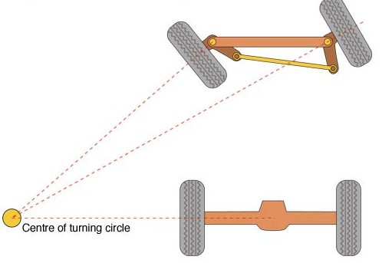
Figure 1 Ackermann Steering

Objective
The objective of this project is to design and build an Ackermann steered robotic vehicle equipped with a SICK Laser measurement sensor; for increased maneuverability in an all-terrain setting. The customer would also like to see 4 wheel steering and independent suspension integrated into the vehicle. In addition, the customer requests basic weather protection including, but not limited to, rain and mud. Final design of the vehicle was completed December of 2008. The final product must be delivered by April of 2009.

Methodology
Tackling this project began with research on current automotive designs of frames, steering, and suspension; combined with additional research on robotic systems and their construction. Before coming up with design concepts, we created 3-d models of the equipment provided to us by CISCOR that were to be integrated. These items included DC Motors, Controllers, and Batteries. A basic frame design was constructed keeping all components of the vehicle in mind. Using this frame, 3 concepts were constructed based on Ackermann steering, but incorporating different suspension designs. The three independent suspensions considered were Macpherson, Double Wishbone, and Trailing Arm. After the concepts were drawn up a sound selection matrix was created to determine the best design. The matrix consisted of two main components, performance, and cost. It was determined that the double wishbone was the best concept, and would continue into the detailed design stage.
A detailed design was created for the vehicle incorporating all necessary equipment and customer needs. As a portion of the iterative design process, the design was put under analysis to verify performance. A finite element analysis was done on the frame to simulate the loading it was undergo. Similarly, Adams Car software was used to simulate suspension travel with our design. Both analysis’ resulted favorably, and verified the quality of our detailed design.
The design itself incorporates many products readily available from known suppliers. What follows is a figure of the final design and a table of products ordered December of 2008.
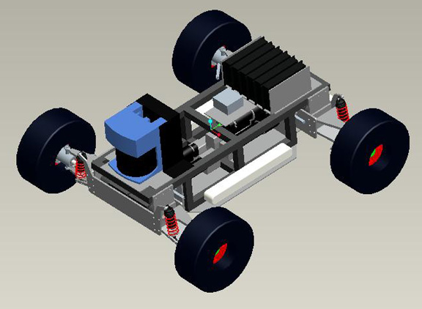
Figure 2 Final Design

Table 1 Parts List

The next step in the project process is to send out our drawing package to a local Tallahassee machine shop for fabrication of the necessary custom components such as the frame. We hope to receive machined components by February 2nd, the first Monday of the month. From this point on we will begin assembly. Should any modifications be necessary, they will be done in house at the college of engineering by available group members.

Expected Results
Currently the plan is to have assembly of the Robot complete by March 27. The end result will be the completed robotic vehicle containing all components provided by CISCOR, as well as have 4-wheel Ackermann steering, and a double wishbone suspension on both the front and rear of the product. Wiring the robot is not the task of the group, as CISCOR will provide all wiring and controls programming for the robot. Although we as a group originally wished to be a part of the testing, it is evident that not only is it outside of the scope of our project, it is also outside our timeline. CISCOR is in agreement, and is well aware of what the group’s objective is as far as a final product is concerned. Ultimately, the products success will depend on its final assembled quality, integration of required features, and customer satisfaction.

Constraints
Investment risks are minimal for CISCOR because of their role as a research facility. Part of research and development includes the possibility of monetary loss through product failure and design flaws. As a group, it is our job to limit the possibilities of such failures. There is no specific budget for the project; however we are still cautious of the amount of money spent. One benefit of our design, is that many of the products are standard and bought from industrial suppliers, therefore can be interchanged, and/or used for other applications by CISCOR.
Currently, the only constraint in front of us is time. Assembly may bring about unforeseen issues that require extra machine time, or even parts. This is why it is imperative to complete fabrication of parts and receive all components from suppliers.

Conclusion
We are currently waiting from ordered parts. Additionally, it is our goal to turn in our drawing packet for manufacturing by Friday January 16 at Shimanski Specialty Machining. During the wait period we will begin working on upcoming deliverables and presentations. Furthermore, after assembly, we will write our operation manual that will consist of detailed assembly instructions. Afterwards, preparation will begin for final presentations and the open house. Should all go well, the group will have the final product and deliverables complete with time to spare.

